DSA Lab :5

Name : Taha Shaikh

BS(III) Section B

1. Print in reverse order: You are asked to design a method in linked list to print data in reverse order. You don’t need to reverse linked list permanently. Public void printReverse()

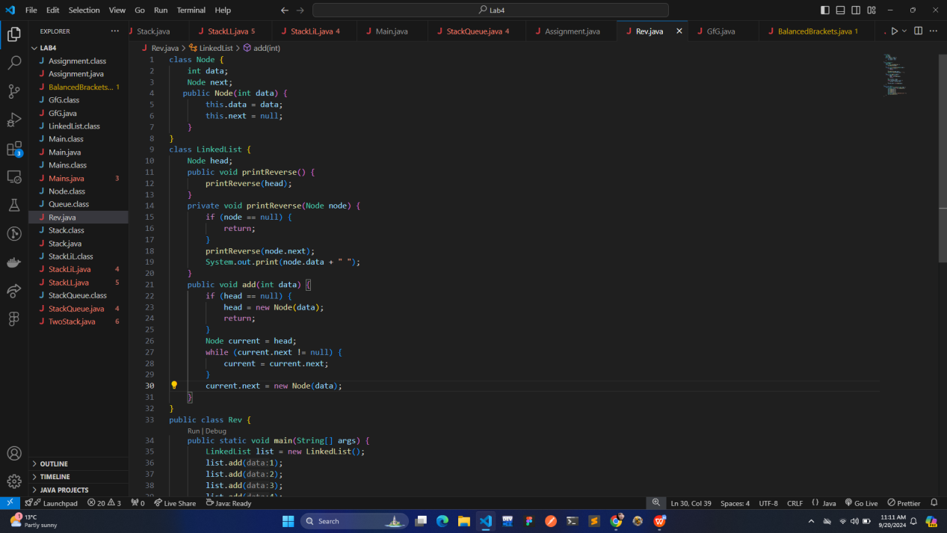

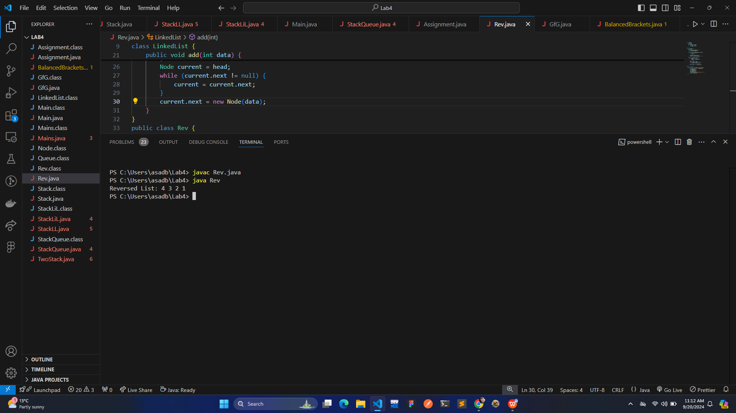

1. Balanced Brackets: Take user string input and check whether it’s balanced or not. Use stack functions. Input may contain any of the bracket among {, [, ( and any number and letters like: ({[a+b]+c}-1) and so on.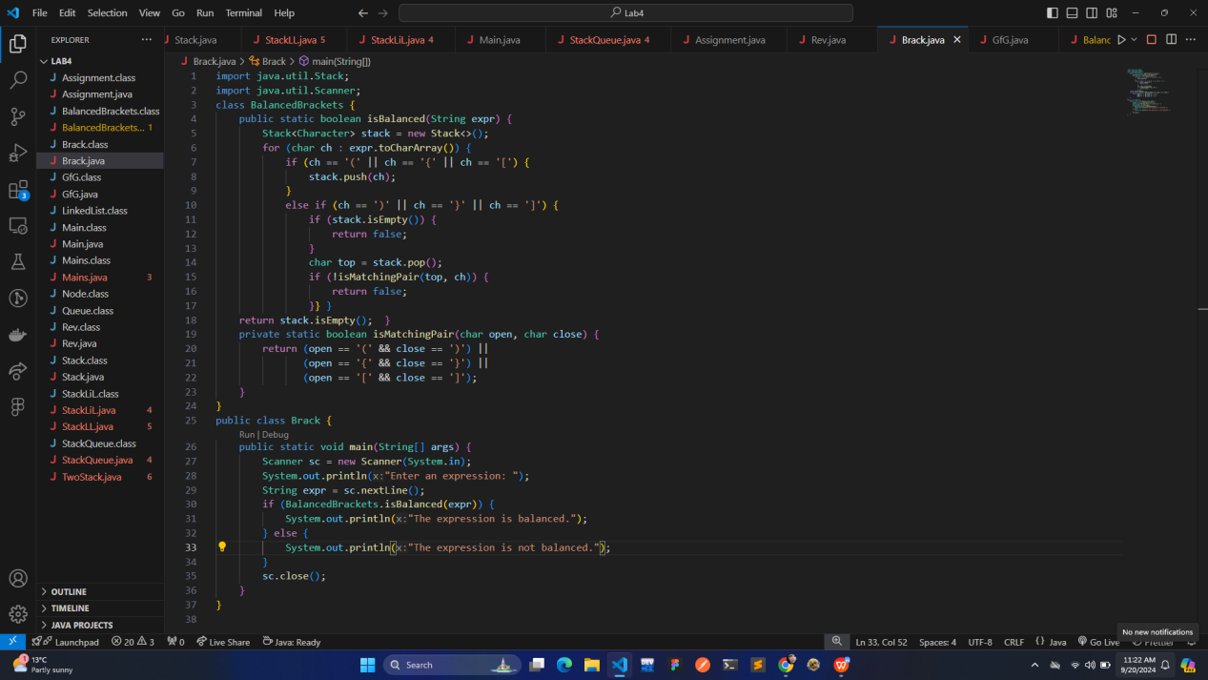

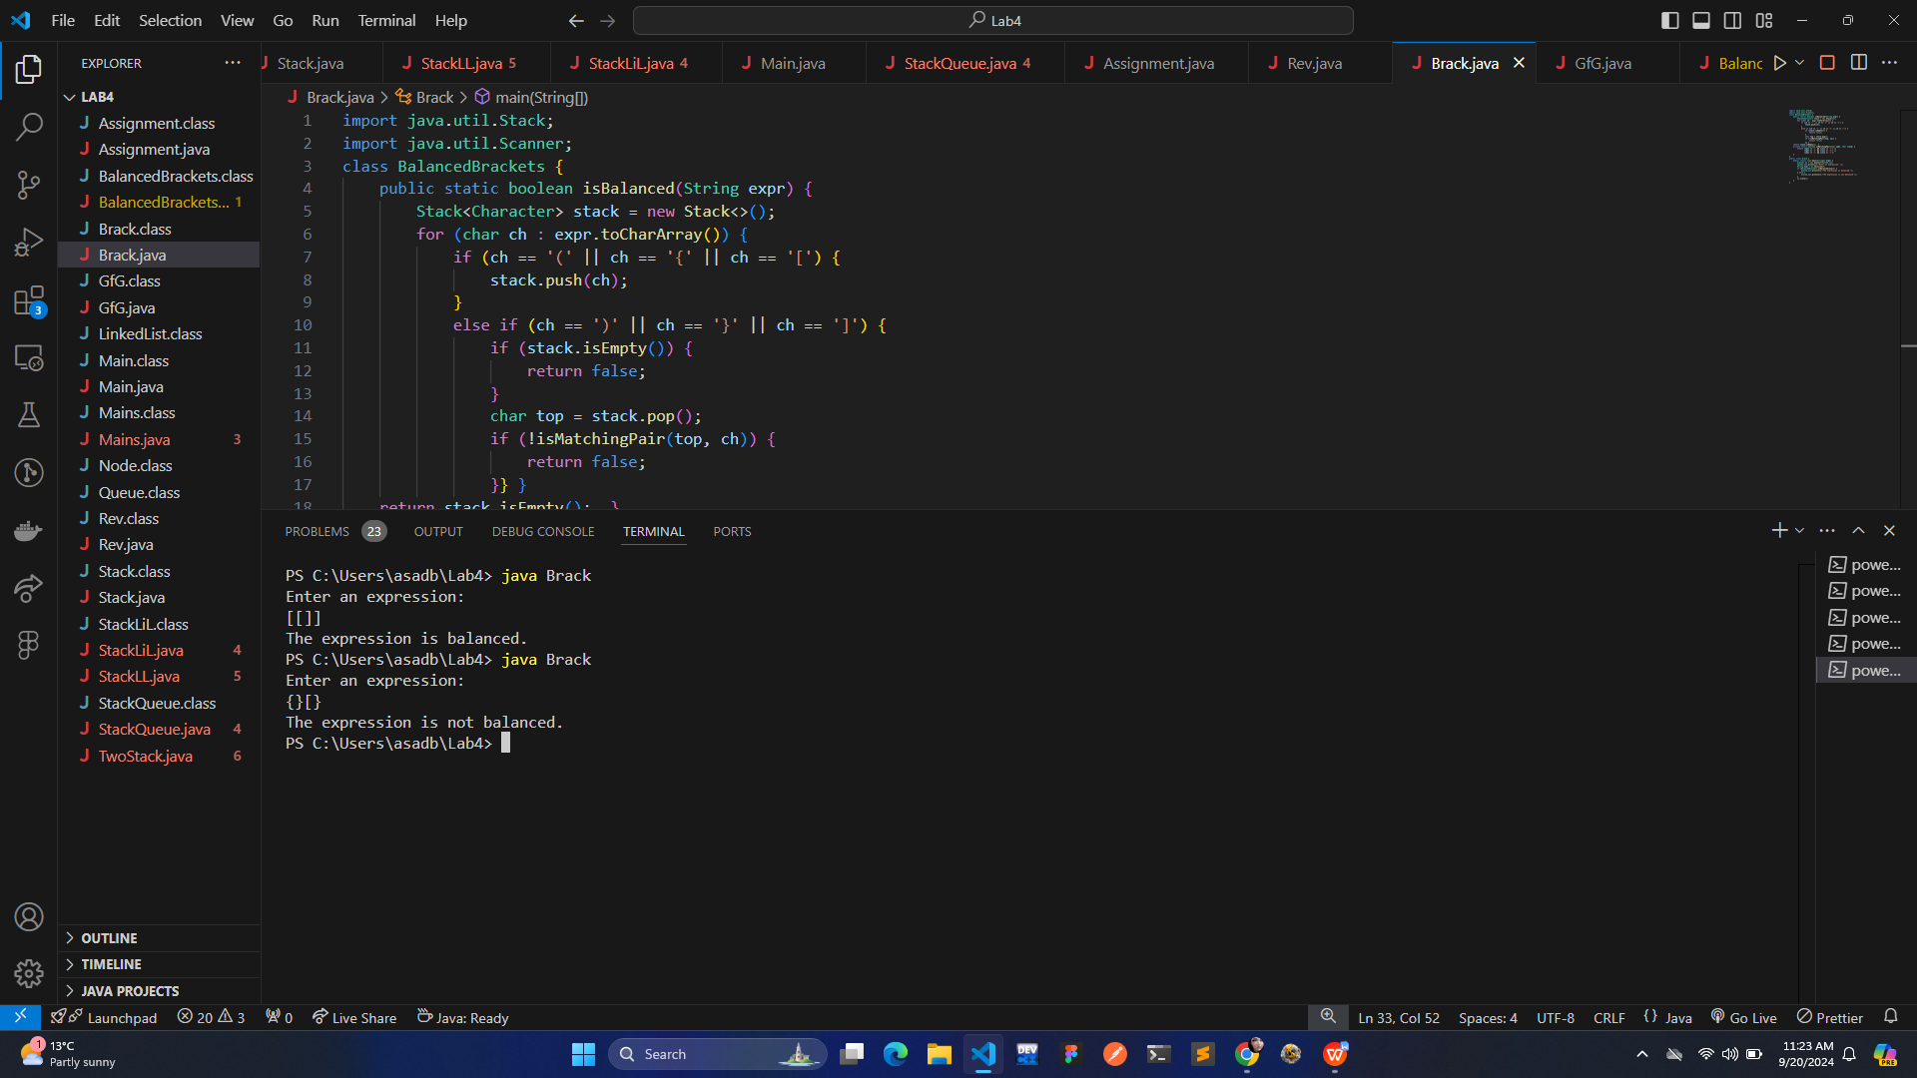

1. FirstSingleLetter: Create the function char firstSingleLetter (const char text [], const int n) which finds and returns the first letter of text that occurs only once. n is the number of characters in the text. Here in this task, it is not allowed to use any help structures - like for example. linkedlist, stack, queue or list. The function will therefore be as O (n2 ). Text contains only the letters A-Z (only uppercase letters, and no spaces).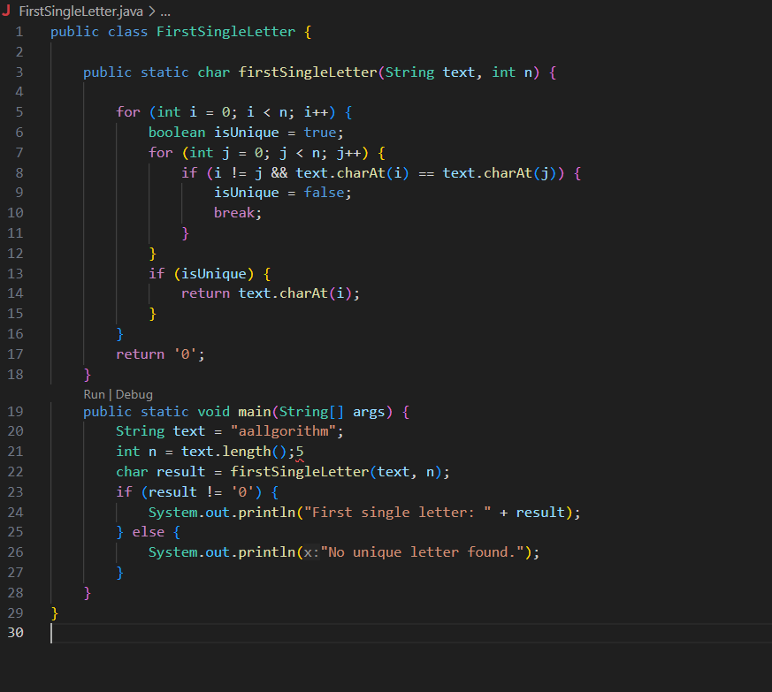

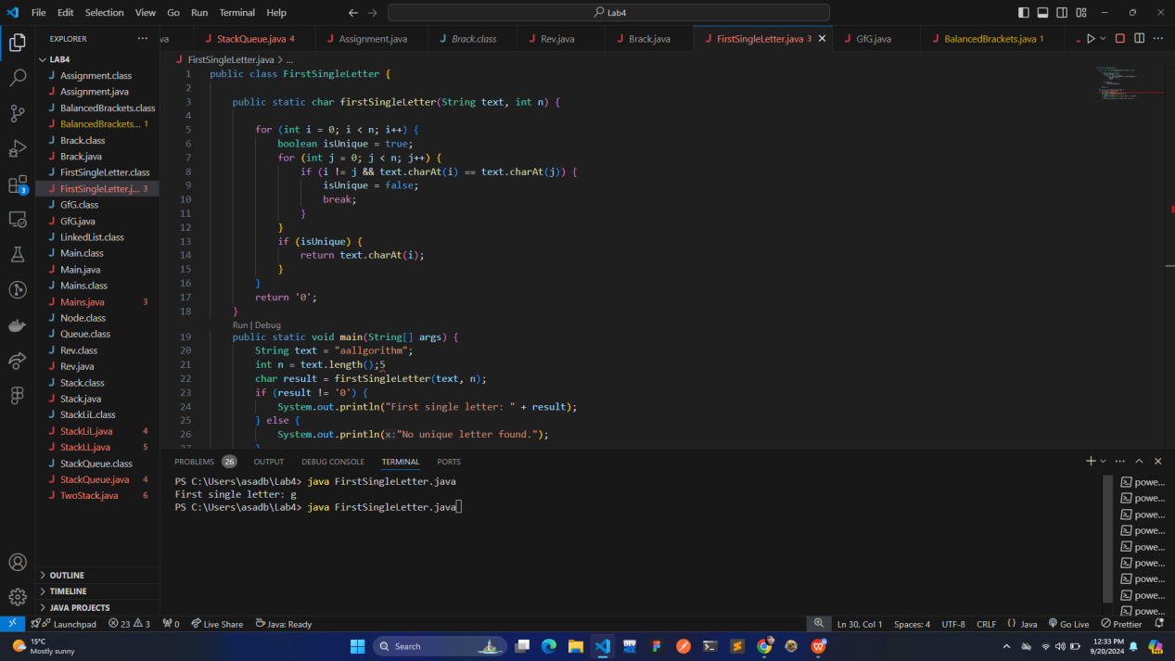

4.Convert Infix expression to Postfix expression using Stack data structure.

